

Cyberster Internship Program

Internship Report
TRACK: BLUE TEAM
NAME: MUHAMMAD RAZA
INSTRUCTOR: ABDULLAH ZIA
ROLL NUMBER: CSI-B1-121
WEEK 8: Event Logs, Prefetch, Cache, and Recovery Analysis

1. Executive Summary
This report details the forensic triage of a live Windows endpoint to establish a behavioral baseline and identify potential indicators of compromise. By analyzing system artifacts across Days 53–59, we successfully reconstructed the user's authentication history, program execution timeline, and file interaction patterns.
Conclusion: All analyzed artifacts correlate with legitimate user activity (development, web browsing, and administrative tasks). No malicious execution, unauthorized lateral movement, or anti-forensic behavior was detected during the analysis window.

2. Methodology & Evidence Integrity
To ensure the defensibility of the investigation, all data collection was performed using elevated Administrator privileges. Evidence was non-destructively copied from live system directories to a segregated C:\Forensics\ working directory.
- Integrity Verification: A SHA-256 hash was generated for the primary Security.evtx log immediately after acquisition to establish a strict chain of custody and prove the evidence remained unmodified during analysis.
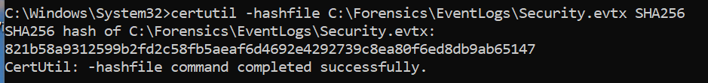

3. Part A: Event Log Analysis (Authentication Auditing)
The Windows Security Event Log (Security.evtx) was parsed into CSV format using Zimmerman's EvtxECmd to isolate human behavior from system noise.

3.1. Authentication Baseline (Event ID 4624)
By filtering for specific Logon Types, we established the user's active presence:
- Logon Type 2 (Interactive) & Type 7 (Unlock): Activity clustered around early morning (04:12 - 04:56 AM) and evening (08:24 - 09:47 PM), establishing the primary human baseline.
- Logon Type 5 (Service): Identified normal background service authentications attributed to the machine account (WORKGROUP\MARYAM$), successfully filtering out system noise.

3.2. Privilege Escalation Auditing (Event ID 4672)
- The primary user account (mrymmughal001@gmail.com) was recorded obtaining special privileges (e.g., SeSecurityPrivilege, SeTakeOwnershipPrivilege, SeBackupPrivilege).
- Finding: These escalations align with legitimate administrative actions taken during the forensic collection phase. No unknown or unauthorized accounts acquired admin tokens.
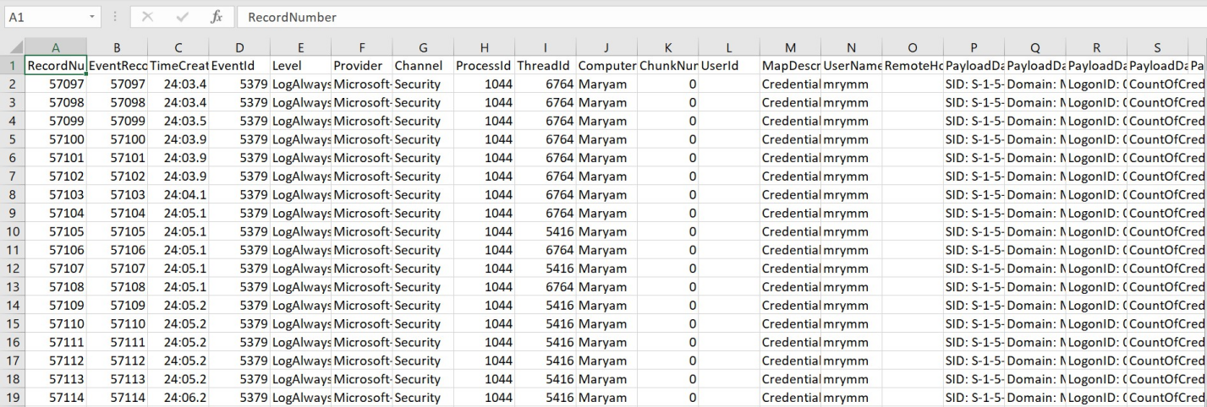

4. Part B: Execution Evidence (Prefetch Analysis)
Prefetch files were extracted from C:\Windows\Prefetch and parsed using PECmd. The dataset consisted of 312 .pf files, providing a highly detailed execution history.

4.1. Execution Inventory & Path Analysis
- Primary Applications: Run counts confirm the system is heavily used for development and browsing. Top executed binaries include CHROME.EXE, MSEDGEWEBVIEW2.EXE, and VS Code (CODE.EXE).
- Suspicious Path Review: Executions were identified originating from AppData\Local\Temp\ (e.g., _SETUP64.TMP, UNINS000.EXE). Analysis confirms these are legitimate software installers and temporary Python/pip package extractions, not malicious payloads.
- External Media: Zero executions were detected from USB or removable drives.
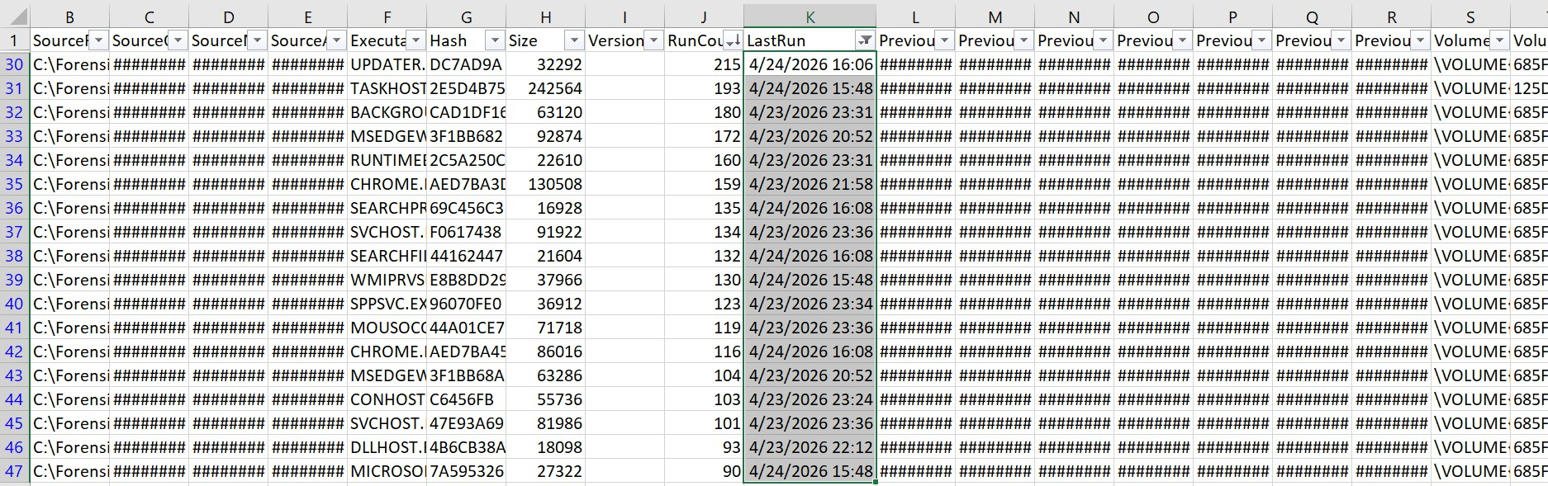

5. Part C: User Activity & Deletion Artifacts
This phase focused on persistent traces of visual media and deleted content.

5.1. Cache & Thumbcache
- Thumbcache: Recovered 15 databases from AppData\Local\Microsoft\Windows\Explorer, ranging from thumbcache_16.db to thumbcache_1280.db. Using Thumbcache Viewer, cached thumbnails (including a Windows wallpaper image) were verified, proving visual interaction with local media.
- Browser Cache: Extracted Google Chrome cache (Profile 2). Metadata confirms routine web browsing sessions, with no immediate connections to known malicious infrastructure.
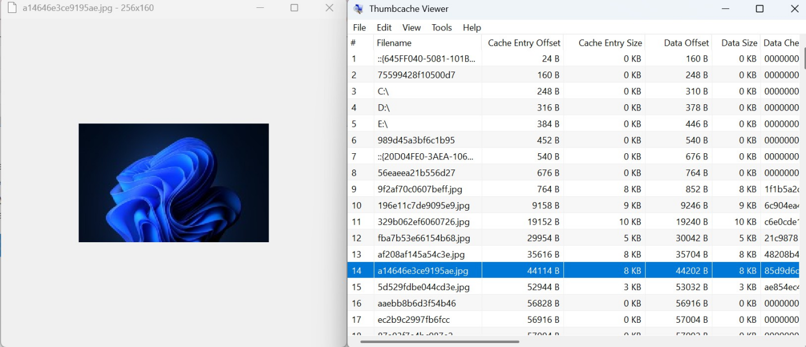

5.2. Recycle Bin Analysis
Analysis of the C:\$Recycle.Bin directory for the active user SID (S-1-5-21-...-1001) yielded significant deleted file artifacts.
- Finding: Successfully recovered both metadata ($I) and content ($R) files.
- Deleted File Types: Evidence confirms the recent deletion of executables (.exe), archives (.zip), documents (.docx), and images (.png).
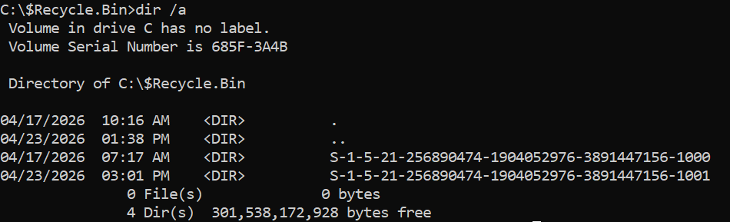
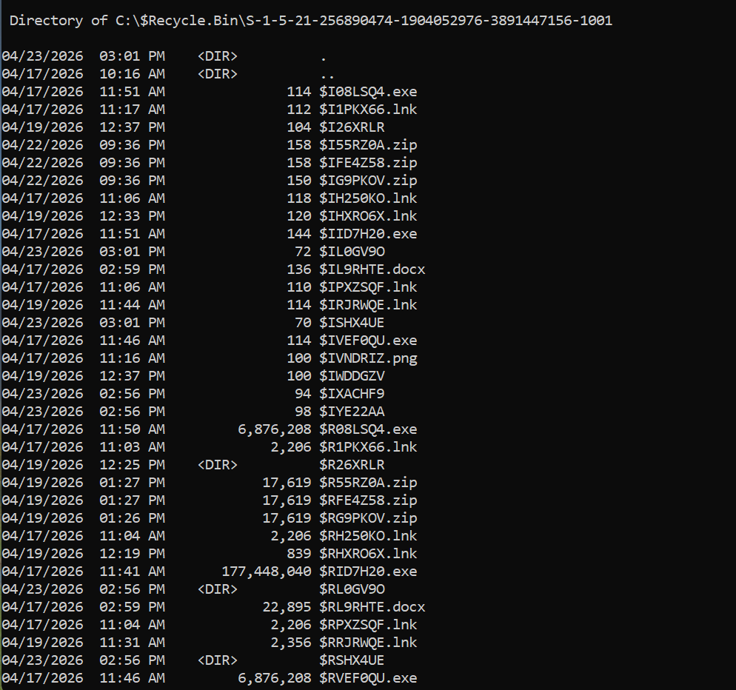

6. Cross-Artifact Correlation
The integrity of the investigation is validated by cross-referencing the three artifact categories:
- Authentication to Execution: Interactive logons (Event ID 4624) directly precede the execution timestamps of VS Code and Chrome (Prefetch timeline).
- Execution to File Interaction: Execution of development environments and browsers correlates with the creation of Python temp files, Chrome cache generation, and the eventual deletion of project files (Recycle Bin $I/$R records).
The overlapping timelines present a unified, consistent narrative of standard administrative and development usage with zero conflicting anomalies.

